**PROJECT TITLE**

**SNAKE, WATER, GUN GAME**

PROJECT MEMBER: PAVULURI LOLA YASWANTHI(RA2111030010256)

**ABSTRACT**

SNAKE, WATER, GUN GAME is a fun game to play which is similar to rock, paper, scissor game in our daily lives. Usually people play this game with their respective friends in their free time. But when there are no people around them can play this fun game with their own computer by simply executing this program and kill their time. The person who plays chooses one option from the three options snake, water, gun and also computer chooses one from the three options and by evaluating those two choices made by the person and computer the output is generated. The main goal of this project is to develop a game which makes people not to feel bored and alone when they play this game. For example, if the two choices are snake and water then snake drinks the water and snake wins, if water and gun then gun sinks in water and water wins or if they choose snake and gun then gun fires snake and gun wins. Result is generated based on the choices provided. We are going to design this program using functions and control statements in c language. On the basis of this idea we design a project in c language to play this fun game.

**ALGORITHM**

**STEP 1: Start**

**STEP 2:** Define a function called

SnakeWaterGun(char you, char comp)

**STEP 3:** Use if and if else, it compares the inputs to decide who won the round.

STEP 3.1: Returns 1 if you win.

STEP 3.2: Returns -1 if you lose.

STEP 3.3: Returns 0 if draw.

**STEP 4:** Initialize a function srand()

STEP 4.1: If number<33, comp chooses S.

STEP 4.2: if number is between 33 and 66, comp chooses W.

STEP 4.3: else comp chooses G.

**STEP 5:** Take the input S, G or W

**STEP 6:** Declare result=SnakeWaterGun(you, comp)

STEP 6.1: From Step 3.1 if result 1 prints You Won!

STEP 6.2: if result is -1 prints You Lose!

STEP 6.3: If result is 0 prints Game Draw

**STEP 7:** Print you choose and computer choose.

**STEP 8:** THE END.

**FLOW CHART**

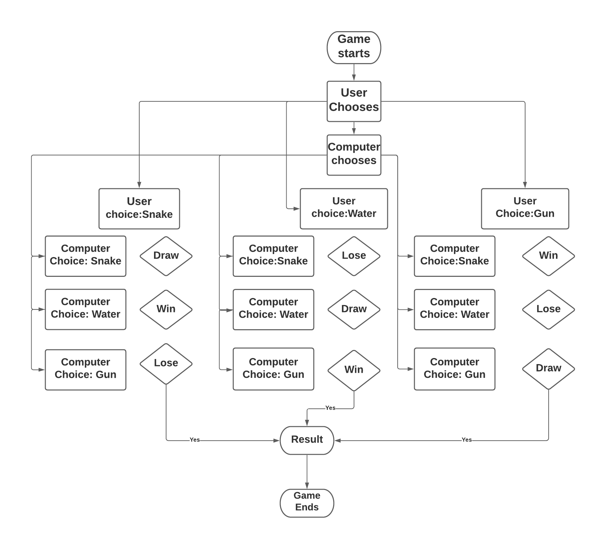

**CODE**

#include<stdio.h>

#include<stdlib.h>

#include<time.h>

int snakeWaterGun(char you, char comp){

// returns 1 if you win, -1 if you lose and 0 if draw

// Condition for draw

// Cases covered: s = snack , w=water , g=gun

// ss

// gg

// ww

if (you == comp){

return 0;

}

// Non-draw conditions

// Cases covered:

// sg

// gs

// sw

// ws

// gw

// wg

if (you=='s' && comp=='g'){

return -1;

}

else if(you=='g' && comp=='s'){

return 1;

}

if (you=='s' && comp=='w'){

return 1;

}

else if(you=='w' && comp=='s'){

return -1;

}

if(you=='g' && comp=='w'){

return -1;

}

else if (you=='w' && comp=='g'){

return 1;

}

}

int main(){

char you, comp;

srand(time(0));

int number = rand()%100 + 1;

if(number<33){

comp = 's';

}

else if(number>33 && number<66){

comp='w';

}

else{

comp='g';

}

printf("Enter 's' for snake, 'w' for water and 'g' for gun\n");

scanf("%c", &you);

int result = snakeWaterGun(you, comp);

if(result ==0){

printf("Game draw!\n");

}

else if(result==1){

printf("You won!\n");

}

else{

printf("You Lose!\n");

}

printf("You chose %c and computer chose %c. ", you, comp);

return 0;

}

**RESULT:**

**INPUT**

s

**OUTPUT**

You won!

You chose s and computer chose w

**INPUT**

w

**OUTPUT**

You Lose!

You chose w and computer chose s

**INPUT**

g

**OUTPUT**

Game draw!

You chose g and computer chose g

**THANK YOU**